http://www.dotnettricks.com/learn/angularjs/what-is-angularjs-and-why-to-use-it:
What is AngularJS and Why to use it?
AngularJS is an open-source JavaScript framework developed by Google. It helps you to create single-page applications, one-page web applications that only require HTML, CSS, and JavaScript on the client side. It is based on MV-* pattern and build well structured, easily testable, and maintainable front-end applications.
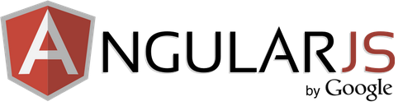
AngularJS has changed the way to web development. It does not based on jQuery to perform its operations. Till now you are using ASP.NET, ASP.NET MVC, PHP, JSP, Ruby on Rails for web development but now you can do your complete web development by using most powerful and adaptive JavaScript Framework AngularJS. There is no doubt, JavaScript frameworks like AngularJs, Ember etc. are the future of web development.

How AngularJS is different from other JavaScript Framework?
- AngularJS markup lives in the DOM.
- AngularJS uses plain old JavaScript objects.
- AngularJS is leverages with Dependency Injection.
Today, AngularJS is most popular and dominant JavaScript framework for professional web development. It is well suited for small, large and any sized web apps and web application. This graph of Google Search Trends shows the interest of developers into JavaScript frameworks over time:
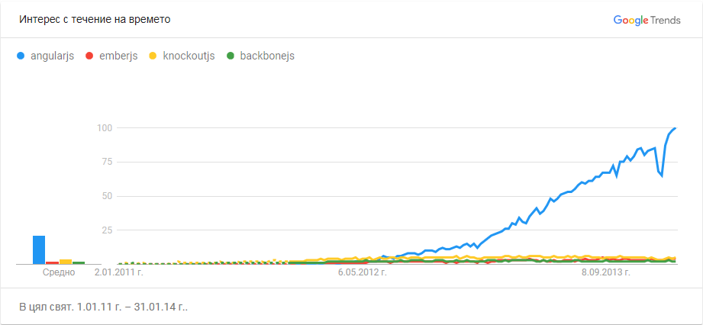

Why Angular JS?
There are numerous of reasons to choose AngularJS as you web development framework. Some of them are listed below:
- It is based on MVC pattern which helps you to properly organize your web apps or web application.
- It extends HTML by attaching directives to your HTML markup with new attributes or tags and expressions in order to define very powerful templates.
- It also allows you to create your own directives, crafting reusable components that fill your needs and abstracting away all the DOM manipulation logic.
- It supports two-way data binding i.e. connects your HTML (views) to your JavaScript objects (models) seamlessly. In this way your model will be immediately reflected into your view without the need for any DOM manipulation or event handling (with jQuery).
- It encapsulates the behavior of your application in controllers which are instantiated with the help of dependency injection.
- It supports services that can be injected into your controllers to use some utility code to fulfill your need. For example it provides $http service to communicate with REST service.
- It helps you to structure and test your JavaScript code very easily.
- Also, AngularJS is mature community to help you. It has widely support over the internet.

AngularJS Developmet IDE
Here is a small list of popular IDE used for AngularJS development.
- Visual Studio 2012/2013 Express or higher
- Eclipse
- WebStorm
- Sublime Text
- TextMate

Understanding Features of AngularJS
http://www.dotnettricks.com/learn/angularjs/understanding-features-of-angularjs:
AngularJS is most powerful and adaptive JavaScript framework by the web developers and designers. In this article, you will learn the most important features of AngularJS and how they can help you to make your app awesome.

AngularJS Features
- Modules
- Directives
- Templates
- Scope
- Expressions
- DataBinding
- MVC (Model, View & Controller)
- Validations
- Filters
- Services
- Routing
- Dependency Injection
- Testing

Modules
AngularJS modules divides your web application into small, reusable and functional components which can be integrated with other web applications. Each module is identified by a unique name and can be dependent on other modules.

Creating an AngularJS module
- <script type="text/javascript">
- angular.module('myApp',[]);
- angular.module('myApp',['dependentModule1','dependentModule2']);
- </script>

Using an AngularJS module into your app
You can bootstraps your app by using your angularJS module as given below:
- <html ng-app="myApp">
- <head>...</head>
- <body>...</body>
Inside your angularjs module you can define following components:
- Controllers
- Services
- Factories
- Filters
- Directives etc.

Directives
AngularJS directives are used to extend the HTML vocabulary i.e they decorate html elements with new behaviors and help to manipulate html elements attributes in interesting way.
There are some built-in directives provided by angularjs like as ng-app, ng-controller, ng-repeat, ng-model etc. You can also create your own custom directive.

Using ng-repeat in Template
- <!-- ng-repeat directive -->
- <ul ng-controller='ProductController'>
- <li ng-repeat='product in Products'> = </li>
- </ul>

- <script>
- function ProductController($scope){
- $scope.Products = [{name: 'Soap', price: 120},
- {name: 'Shampoo', price: 100},
- {name: 'Hair Oil', price: 60}];
- }
- </script>

Templates
AngularJS templates are just plain old HTML that contains Angular-specific elements and attributes. AngularJS used these templates to show information from the model and controller.
Inside your angularjs templates you can define following angular elements and attributes:
- Directive
- Angular Markup ()
- Filters
- Form controls

Creating Template
- <html ng-app>
- <!-- Body tag with ngController directive -->
- <body ng-controller="MyController">
- <input ng-model="foo" value="bar">
- <!-- Button tag with ng-click directive, and string expression 'buttonText' is wrapped in "" markup -->
- <button ng-click="changeFoo()"></button>
- <script src="angular.js">
- </body>
- </html>

Expressions
Angular expressions are JavaScript-like code snippets that are usually placed in bindings such as . AngularJS expressions doesn't support control flow statements(conditionals, loops, or exceptions). These supports filters to format data before displaying it.
There are some valid angularjs expressions:
- 3
- 2
- false
- 2

Data Binding
AngularJS data-binding is the most useful feature which save you from writing a considerable amount of boilerplate code. Now, developers are not responsible for manually manipulating the DOM elements and attributes to reflect model changes. AngularJS provides two-way data-binding to handle the synchronization of data between model and view.
The data-binding directives helps you to bind your model data to your app view. Use ng-model directive to create a two way data-binding between the input element and the target model.
- <div ng-controller='HelloController'>
- <input ng-model='name'/><!-- two way -->
- <p>Hello </p> <!-- one way -->
- </div>

- <script>
- function HelloController($scope)
- {
- $scope.name = 'Dot Net Tricks'
- }
- </script>

Scope
Scope is an object that refers to the application model. It acts as a context for evaluating expressions. Typically, it acts as a glue between controller and view. Scopes are hierarchical in nature and follow the DOM structure of your angularjs app.
Each angular app has a single scope ($rootscope) which mapped to the ng-app directive element.

Creating $scope in controllers
- <script>
- function ProductController($scope){
- $scope.Products = [{name: 'Soap', price: 120},
- {name: 'Shampoo', price: 100},
- {name: 'Hair Oil', price: 60}];

- }
- </script>

Using Scope in Template
- <!-- ng-repeat directive -->
- <ul ng-controller='ProductController'>
- <li ng-repeat='product in Products'> =
- </li>
- </ul>

MVC (Model, View & Controller)
AbgularJS is a MVC framework. It does not implement MVC in the traditional way, but rather something closer to MVVM Model-View-ViewModel).

The Model
Models are plain old JavaScript objects that represent data used by your app. Models are also used to represent your app's current state.

The ViewModel
A viewmodel is an object that provides specific data and methods to maintain specific views. Basically, it is a $scope object which lives within your angularjs app's controller. A viewmodel is associated with a HTML element with the ng-model & ng-bind directives.

Creating an AngularJS Controller with ViewModel
- <script type="text/javascript">
- //defining main controller
- app.controller('mainController', ['$scope', function($scope) {

- //defining book viewmodel
- $scope.book =
- {
- id: 1,
- name: 'AngularJS Interview Questions and Answers',
- author: 'Shailendra Chauhan',
- };
- }]);
- </script>

The Controller
The controller define the actual behavior of your app. It contains business logic for the view and connects the right models to the right views. A controller is associated with a HTML element with the ng-controller directive.

The View
The view is responsible for presenting your models data to end user. Typically it is the HTML markup which exists after AngularJS has parsed and compiled the HTML to include rendered markup and bindings.

Using an AngularJS controller into your app
- <!-- The View -->
- <div ng-controller="mainController">
- Id: <span ng-bind="book.id"></span>
- <br/>
- Name:<input type="text" ng-model="book.name" />
- <br/>
- Author: <input type="text" ng-model="book.author" />
- </div>

Validation
AngularJS form validation enables you to develop a modern HTML5 form that is interactive and responsive. AngularJS provides you built-in validation directives to achieve form validation and they are based on the HTML5 form validators. You can also create your own custom validators.
Here is a list of angularjs directive which can be apply on a input field to validate it's value.
- <inputtype="text"
- ng-model="{ string }"
- [name="{ string }"[
- [ng-required="{ boolean }"]
- [ng-minlength="{ number }"]
- [ng-maxlength="{ number }"]
- [ng-pattern="{ string }"]
- [ng-change="{ string }"]>
- </input>

Filter
Filters are used to format data before displaying it to the user. They can be used in view templates, controllers, services and directives. There are some built-in filters provided by angularjs like as Currency, Date, Number, OrderBy, Lowercase, Uppercase etc. You can also create your own filters.

Filter Syntax

Filter Example
- <script type="text/javascript">
- $14.00 //returns $14.00
- </script>

Services
Services are reusable singleton objects that are used to organize and share code across your app. They can be injected into controllers, filters, directives.

$http Service
- <script>
- $http.get('/products')
- .success(function(data) {
- $scope.products = data;
- });
- });
- </script>
AngularJS offers several built-in services (like $http, $provide, $resource,$window,$parse) which always start with $ sign. You can also create your own services

Routing
AngularJS Routing helps you to divide your app into multiple views and bind different views to Controllers. The magic of Routing is taken care by a angularjs service $routeProvider. $routeProvider service provides method .when() and .otherwise() to define the routes for your app. Routing has dependency on ngRoute module.
- <script type="text/javascript">
- var myApp = angular.module('myApp', ['ngRoute']);

- myApp.config(['$routeProvider',
- function($routeProvider) {
- $routeProvider.
- when('/products', { //route
- templateUrl: 'views/products.html',
- controller: 'productController'
- }).
- when('/product/:productId', { //route with parameter
- templateUrl: 'views/product.html',
- controller: 'productController'
- }).
- otherwise({ //default route
- redirectTo: '/index'
- });
- }]);
- </script>

Dependency Injection
Dependency Injection (DI) is a software design pattern that deals with how components get hold of their dependencies. AngularJS comes with a built-in dependency injection mechanism. You can divide your angularjs app into multiple different types of components which angularjs can inject into each other.

Dependency Annotation
There are following three ways of injecting dependencies into your code:
- Implicitly from the function parameter names
  - <script type="text/javascript">
  - function MyController($scope, greeter) {
  - // ...
  - }
  - </script>
- Using the $inject property annotation
  - <script type="text/javascript">
  - var MyController = function(renamed$scope, renamedGreeter) {
  - ...
  - }

  - MyController['$inject'] = ['$scope', 'greeter'];
  - </script>
- Using the inline array annotation
  - <script type="text/javascript">
  - someModule.factory('greeter', ['$window', function(renamed$window) {
  - // ...
  - }]);
  - </script>

Testing
AngularJS is designed to be testable so that you can test your AngularJS applications as easy as possible. It also comes with an end-to-end and unit test runner setup.

A Look into AngularJS Compilation Process
http://www.dotnettricks.com/learn/angularjs/a-look-into-angularjs-compilation-process:

